Report

Date
Team ID | MCA
Project Name | Smartphone Usage, Digital Addiction & Well-Being Analytics
Maximum Marks | 5 Marks

A report is a comprehensive document that presents the results of data analysis in a structured and understandable manner. For the project “Smartphone Usage, Digital Addiction & Well-Being Analytics,” the Power BI report is designed to analyze smartphone usage patterns, digital addiction indicators, and their relationship with lifestyle and well-being factors.
The report combines different visualizations such as KPI cards, bar charts, column charts, donut charts, and scatter plots to present important findings. Interactive filters and slicers allow users to explore the data based on categories such as age group, gender, smartphone usage level, and addiction status.
The report helps users understand patterns in screen time, application usage, digital addiction, sleep duration, physical activity, stress, and productivity. The information can be used for analytical and awareness purposes to understand digital usage patterns.
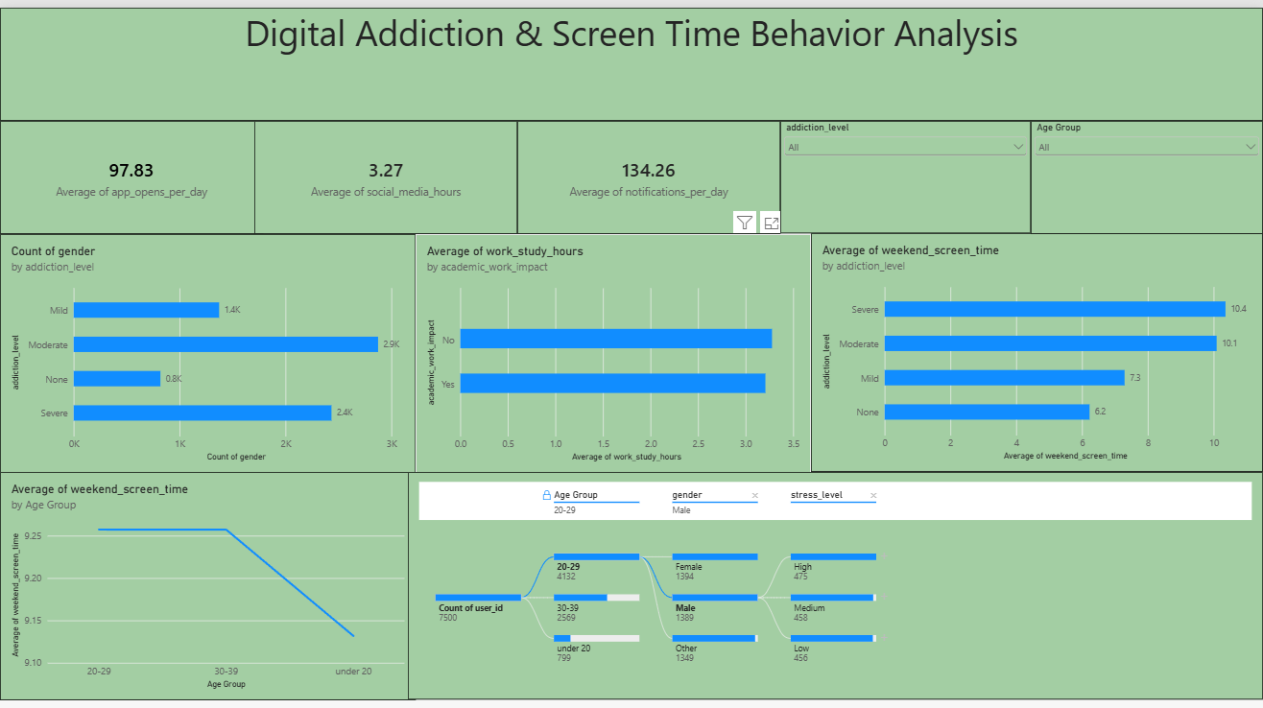

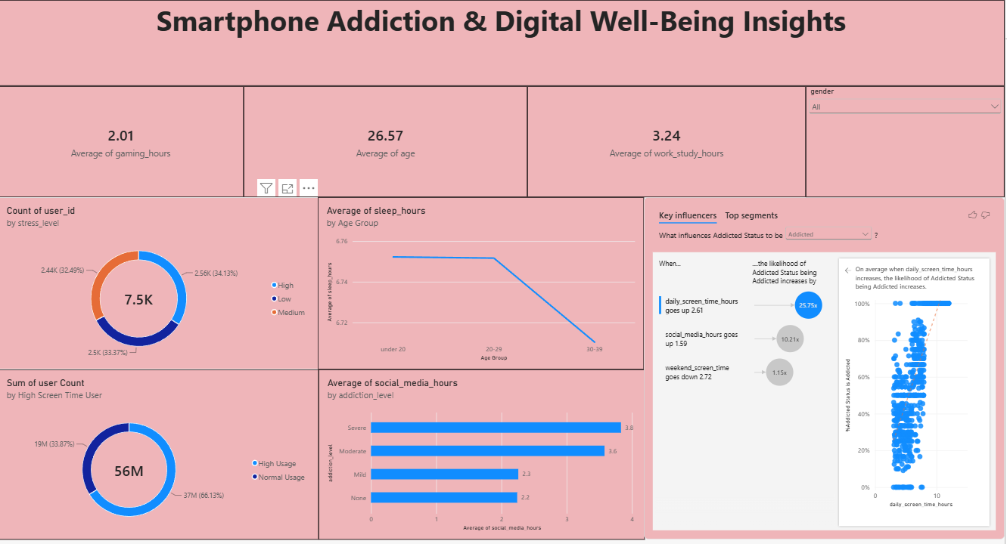

Observations drawn from reports in Power BI
Smartphone Usage Analysis
- The report shows an average of 97.83 app opens per day.
- The average social media usage is 3.27 hours.
- The average gaming usage is 2.01 hours.
- The average number of notifications received per day is 134.26.
These metrics provide an overview of smartphone interaction and different types of digital activity in the dataset.
2. Addiction Level Analysis
The report categorizes users into four addiction levels:
- Moderate: approximately 2.9K users
- Severe: approximately 2.4K users
- Mild: approximately 1.4K users
- None: approximately 0.8K users
The visualization allows the distribution of users across the different addiction levels to be compared.
3. Weekend Screen Time by Addiction Level
The report shows the following average weekend screen time by addiction level:
- Severe: 10.4 hours
- Moderate: 10.1 hours
- Mild: 7.3 hours
- None: 6.2 hours
This visualization shows how average weekend screen time differs across the addiction-level categories in the dataset.
4. Academic Work/Study Analysis
The report compares average work/study hours according to academic work impact:
- No academic work impact: approximately 3.3 hours
- Academic work impact: approximately 3.2 hours
This comparison provides information about work/study hours for the two academic-work-impact categories shown in the report.
5. Age Group Analysis
The report contains three age groups:
- 20–29: 3,692 users
- 30–39: 2,569 users
- Under 20: 1,239 users
The decomposition tree also allows the user distribution to be explored further by age group, gender, and stress level.
6. Sleep Hours by Age Group
The report shows differences in average sleep hours among the age groups:
- 20–29: approximately 6.76 hours
- Under 20: approximately 6.73 hours
- 30–39: approximately 6.71 hours
The line chart provides a comparison of average sleep duration across the age groups.
7. Stress Level Distribution
The report categorizes users into three stress levels:
- High: approximately 2.56K users (34.13%)
- Medium: approximately 2.50K users (33.37%)
- Low: approximately 2.44K users (32.49%)
The donut chart provides the distribution of users across the three stress-level categories.
8. Social Media Usage by Addiction Level
The report shows average social media hours by addiction level:
- Severe: 3.8 hours
- Moderate: 3.6 hours
- Mild: 2.3 hours
- None: 2.2 hours
This visualization compares social media usage across the addiction-level categories.
9. High Screen-Time User Analysis
The report includes a visualization comparing High Usage and Normal Usage users.
The displayed values are:
- High Usage: approximately 19M (33.87%)
- Normal Usage: approximately 37M (66.13%)
- Total displayed user count: 56M
These values are presented exactly as displayed in the Power BI visual.
10. Key Influencers Analysis
The Key Influencers visual analyzes factors associated with Addicted Status. The report shows:
- When daily screen time increases by 2.61 hours, the likelihood of Addicted Status increases by 25.96× in the displayed analysis.
- When social media hours increase by 1.59 hours, the likelihood increases by 10.24×.
- When weekend screen time increases by 2.72 hours, the likelihood increases by 1.16×.
These are associations identified by the Power BI Key Influencers visual, rather than proof that these factors directly cause addiction.
Key Project Insights
- 7,500 users are included in the analyzed dataset.
- Users show an average weekend screen time of 9.24 hours.
- The overall average sleep duration is 6.74 hours.
- Users have an average of 97.83 app opens per day.
- Average social media usage is 3.27 hours.
- Users receive an average of 134.26 notifications per day.
- The analysis considers addiction level, age group, gender, stress level, screen time, sleep, social media usage, and app usage.
- The Power BI report provides interactive analysis to understand different patterns of smartphone usage and digital well-being.

